1. b) Plate Tectonics – What is this theory?
Alfred Wegner and Continental Drift
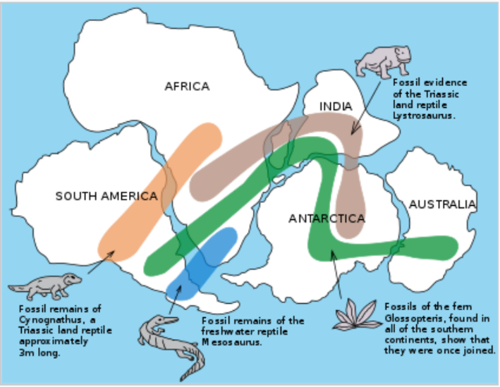
In 1915, Alfred Wegner proposed his theory of Continental Drift. He proposed that the continents were once all joined together in a ‘supercontinent’ he called Pangaea. Over 180 million years ago this supercontinent began to "break up" due to continental drift. His evidence for the new theory was
- The continents could be fit together (like a jigsaw puzzle).
- Worldwide distribution of fossils from the same time period.
- Rock layers in mountain chains on one continent match up with the rock layers in mountain chains on another continent.
- Rocks and fossils in many places don’t match the present climate or conditions.
During Wegner’s lifetime his theory was not widely believed. Wegner could not explain what would cause such huge sections of the earth to move so slowly and for so long. In addition, most people simply accepted that the world was stable – generally because they could not see any change in their lifetime.
Plate Tectonics
During the 20th Century, further evidence arose supporting Wegner’s theory.
- The use of sonar in WWII led to the discovery of underwater trenches and volcanic seams under oceans
- The magnetic record of the ocean floor is a mirror image on either side of seams.
- Satellites have been used to measure the spreading of the ocean floor.
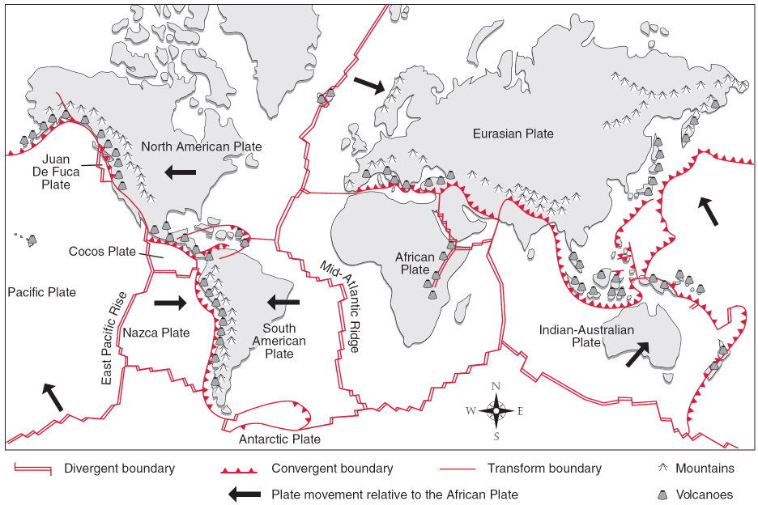
This new evidence lead scientists developed the theory of Plate Tectonics. The theory suggested that the crust of the Earth is split up into seven large plates (see map on the right) and a few smaller ones, all of which are able to slowly move (less than 2.5 cm per year) around on the Earth's surface. They float on the semi-molten mantle rocks, and are moved around by convection currents within the very hot rock.
There are two types of tectonic plates - continental plates and oceanic plates. Continental plates contain continents and are lighter (less dense) than oceanic plates. Oceanic crust is much younger in geologic age than continental crust. Continental crust is on average thicker than oceanic crust.
Questions
- In what year did Alfred Wegner propose his theory of continental drift?

- What was the name of the super continent Wegner proposed?

- List (briefly… summarise) the four main pieces of evidence Wegner used to support his theory?

- Imagine over 100 years ago, without the advent of technology, hearing about Wegners theory that the surface of the earth was constantly moving, albeit very slowly? Would you have believed it? Explain why or why not?

- What new evidence was found during the 20th century to support the theory of continental drift?

- How many plates are named on the map?

- In your own words clearly explain the difference between the theory of continental drift, and the theory of plate tectonics

